Multi-threaded Program Analysis using "perf" Tool
Graduate Systems (CSE638) – PA02

1. Introduction
This project focuses on analyzing multithreaded programs using the Linux perf tool to assess performance, detect bottlenecks, and optimize execution. The study involves developing different types of workloads, implementing a producer-consumer pipeline, and evaluating performance metrics such as CPU usage, memory bandwidth, and context switches.

2. Objectives
- Develop four distinct multithreaded programs to simulate CPU-bound, memory-bound, I/O-bound, and mixed workloads.
- Implement a producer-consumer pipeline using synchronization primitives.
- Utilize perf to analyze execution efficiency and identify bottlenecks.
- Compare the scalability of different workload types by varying thread counts.

3. Implementation

3.1 Part A: Multithreaded Program Variants
Four separate programs were implemented using the pthread library:
- CPU-bound: Performs intensive computations (e.g., matrix multiplication, prime number calculations).
- Memory-bound: Focuses on operations requiring large memory allocations and accesses.
- I/O-bound: Simulates disk I/O or network operations to assess read/write performance.
- Mixed workload: Combines CPU, memory, and I/O tasks to simulate real-world applications.
Each program was executed with different thread configurations (2, 4, 8, 50, 100) to study the effect of thread scaling on performance.

4. Performance Analysis with perf
The following key metrics were analyzed for each program:
- CPU Usage: Measures processor load during execution.
- Memory Bandwidth: Tracks memory reads/writes per second.
- Cache Behavior: Monitors cache references and misses.
- Context Switches: Evaluates efficiency in handling multiple threads.
- Execution Time & Throughput: Determines overall performance.

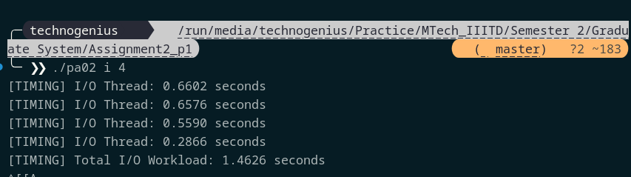
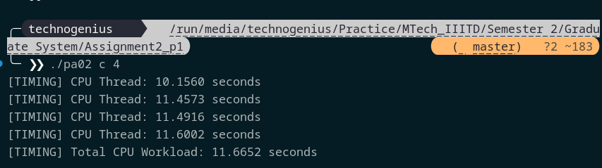
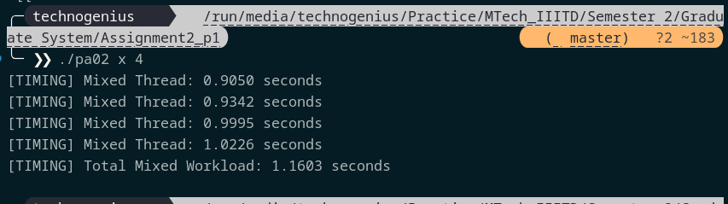
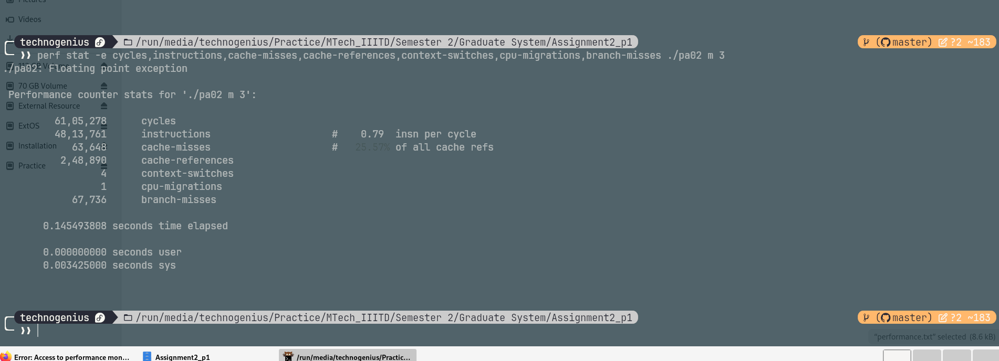
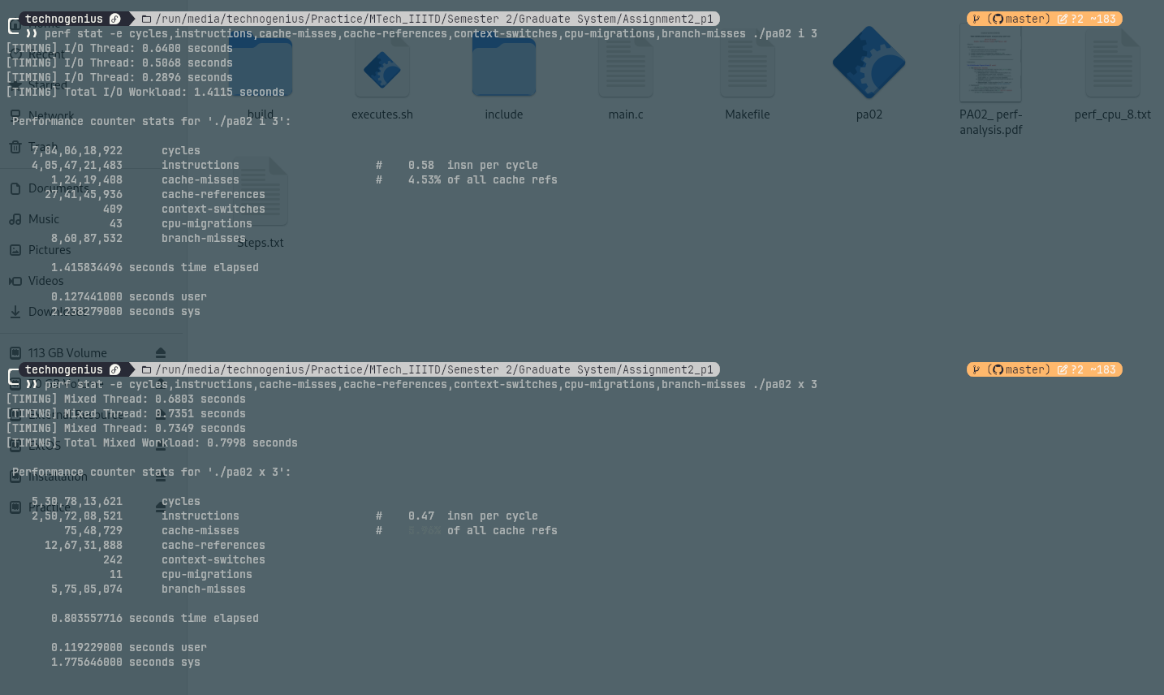
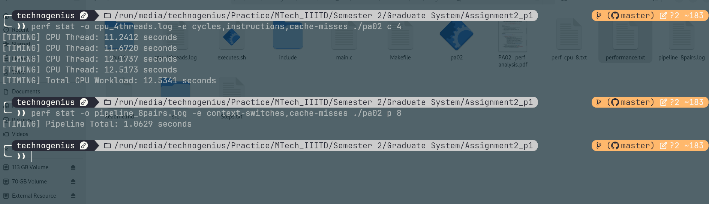

5. Scalability Testing
To assess scalability, each program was executed with increasing thread counts. Observations include:
- CPU-bound programs showed diminishing returns beyond a certain thread count.
- Memory-bound workloads suffered from increased cache misses with more threads.
- I/O-bound tasks exhibited bottlenecks due to disk read/write limitations.
- Mixed workloads demonstrated variable performance based on resource contention.

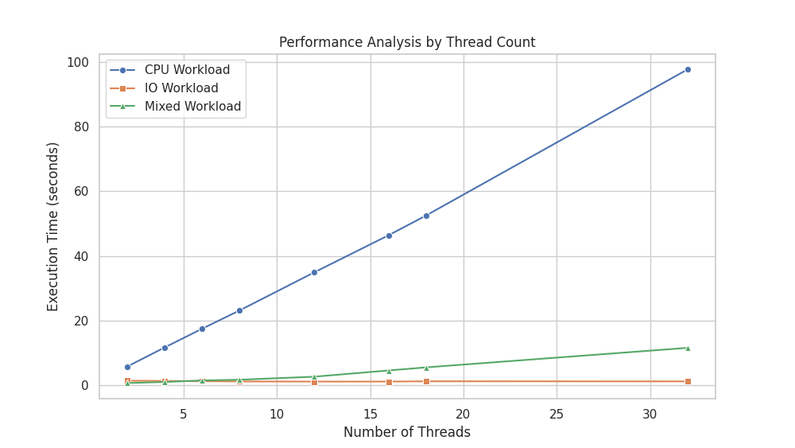
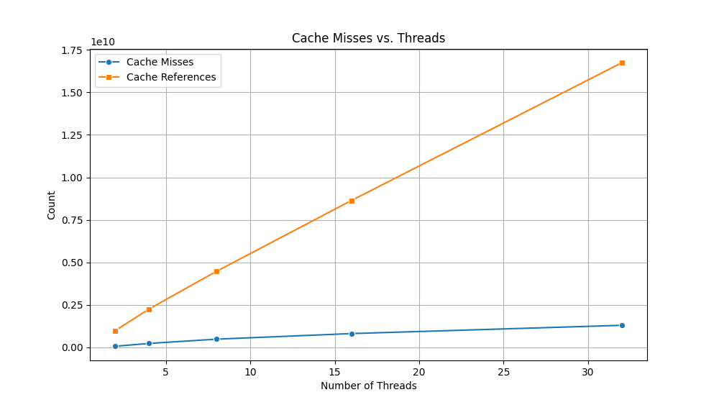

6. Observations and Bottlenecks
- Excessive thread creation led to overhead due to frequent context switching.
- Cache efficiency played a crucial role in memory-bound workloads.
- I/O operations became a limiting factor beyond a certain number of threads.
- The producer-consumer model improved efficiency but required careful synchronization tuning.

7. Conclusion
This project provided insights into multithreaded performance analysis using perf. The results highlighted the importance of workload-specific optimizations, proper thread management, and synchronization techniques for improving performance. Future improvements could include exploring alternative scheduling policies and optimizing memory access patterns.

8. References
- Linux perf Tool Documentation
- Multithreading with Pthreads
- Performance Optimization Techniques

